1. Take current age of the user and calculate his/her birth year.

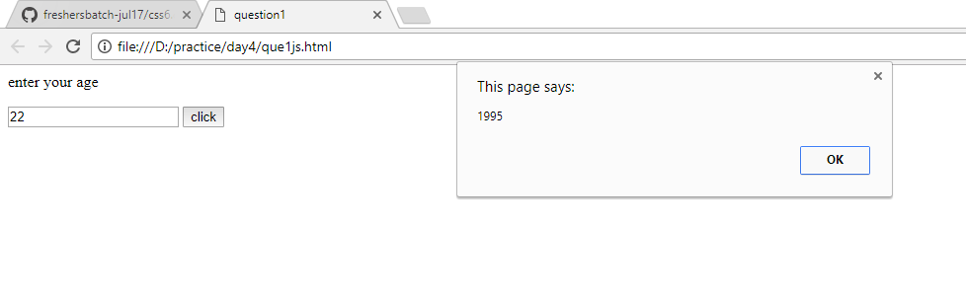

1. Take the name of the user and greet him

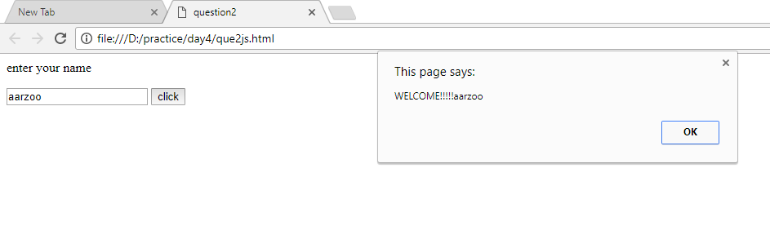

1. Ask a user to provide 2 numbers of divisions. If the second number is zero then show a warning message (alert box).

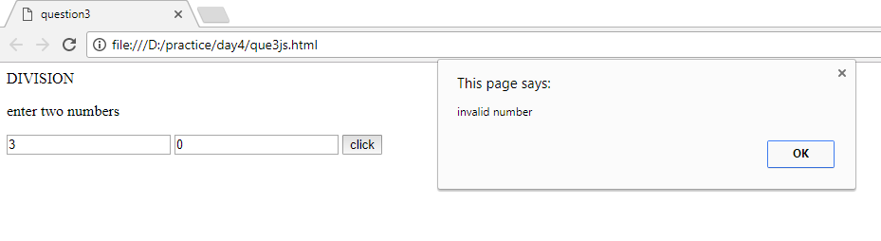

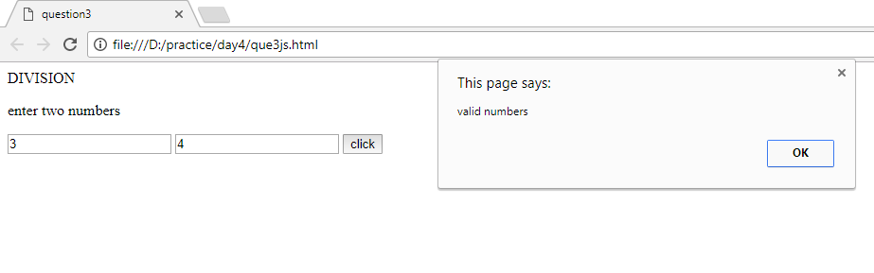

1. Write a program that asks the user to provide a number whose multiplication table is to be generated. Ask user confirmation to continue with next number or quit

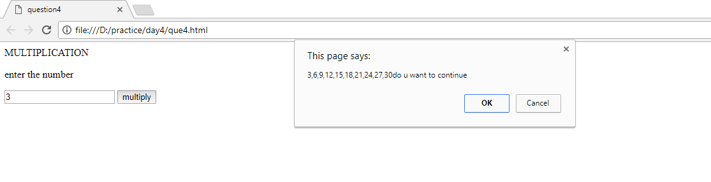

1. Take an alphabet from the user and check if it is a vowel or not.

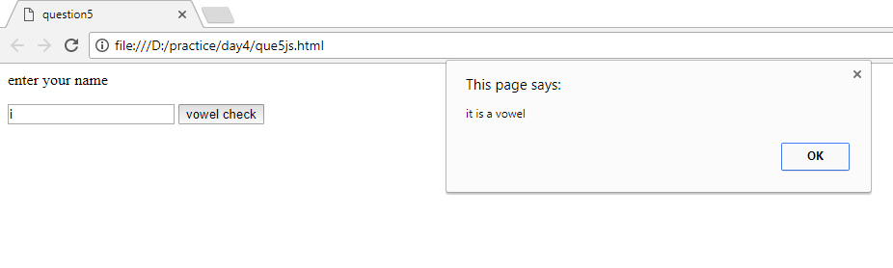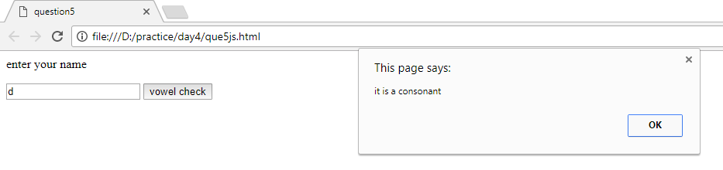

1. Take two numbers from the user and find the prime numbers between this numbers.

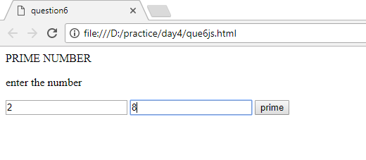

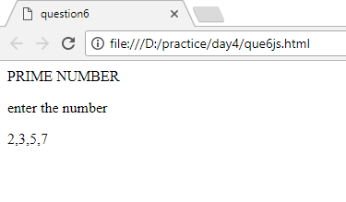

1. Calculate factorial of a number the user submits.

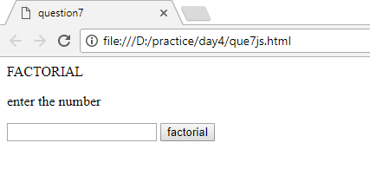

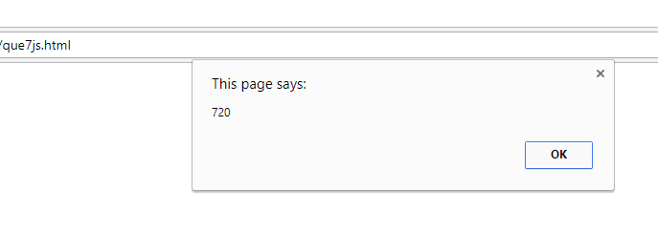

1. Take user id and password from the user. Check whether it is correct. Give three chances. When exhausted give error page.

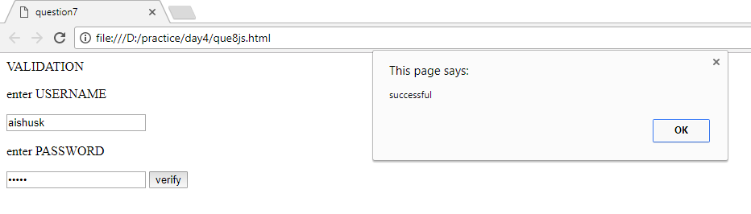

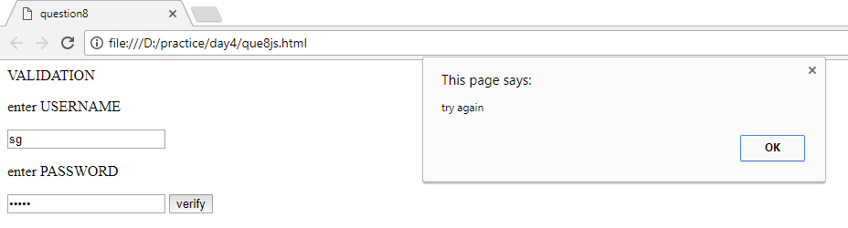

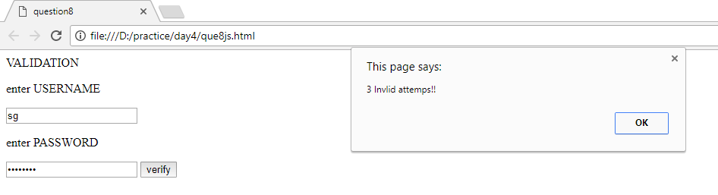

1. Given an array containing numbers. Find max, min, average, total. (Array should have unique numbers)

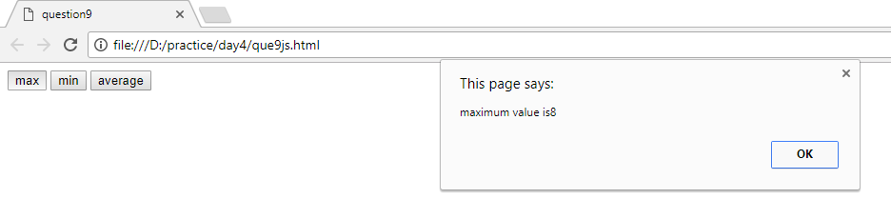

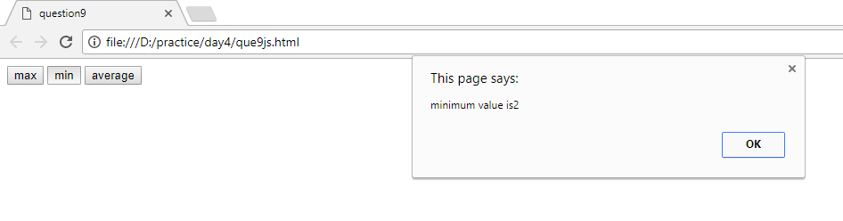

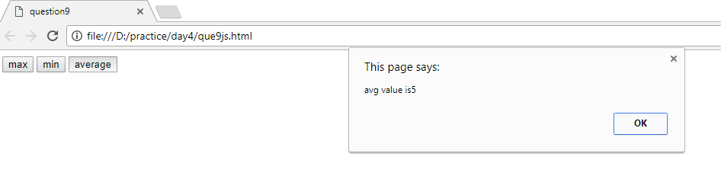

1. Given an array of random numbers ask the user wants ascending /descending sorting and display it.

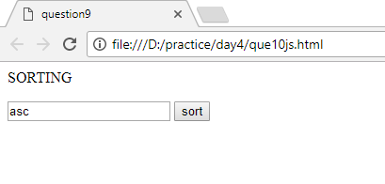

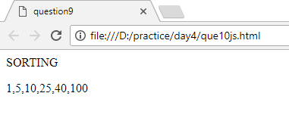

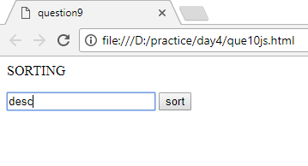

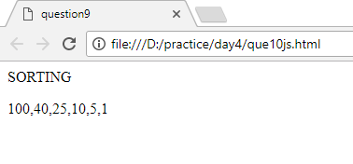

1. Given a sentence write a JavaScript program to calculate the numbers of vowel. Eg (a = 4, e = 5, i=0, o=6, u=9)

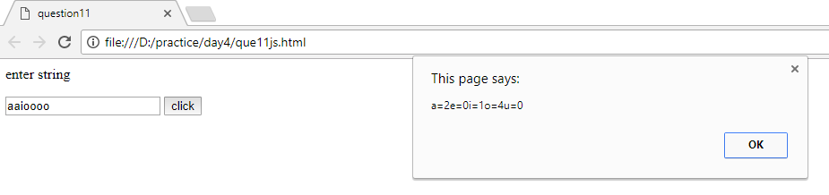

1. Take a word from the user and check if it is a palindrome or a consonant.
2. Take an email id and validate it for correctness.
3. Calculate the number of characters in a sentence.
4. Given a sentence remove excess white spaces from it.